**AEA-Europe Annual**

**Conference**

**2024**

**Paphos, Cyprus**

**6th – 9th November 2024**

# Call and instructions for submissions

The submission of proposals for the 2024 Association for Educational Assessment-Europe annual conference is now open. This document includes the conference theme and describes the different submission formats and how to make a submission. Submissions will be made through EasyAcademia at: <https://www.easyacademia.org/aea2024>

This link to the submission page can also be found on the AEA-Europe website <https://aea-europe.net/> and conference website <https://2024.aea-europe.net/>.

## Please read the guidelines carefully before uploading your proposal(s) to EasyAcademia.

**Important dates**

Main conference:

Pre-conference workshops:

November 7-9, 2024

November 6, 2024

Submission deadline for pre-conference workshops: April 6, 2024 Submission deadline (other than workshops): April 20, 2024 Acceptance notification: June 30, 2024

Registration by presenters: August 31, 2024

Online registration closes: October 6, 2024

Please note that for submissions there will be no deadline extensions.

**Advances in Educational Assessment Practices:**

**Considering the use of Technology, Artificial Intelligence, and Process Data for Assessment in the 21st Century**

Educational assessment has long been an integral part of educational systems worldwide, guiding our understanding of student learning and informing educational policies and practices. Within these systems, paper-and-pencil tests have traditionally been the primary method for assessing students' knowledge and skills. In the 21st century however, with the advancement of technology, the wider adoption of computer-based tests, and the availability of vast amounts of process data, the landscape of educational assessment is evolving very rapidly. Moreover, the recent emergence and wide availability of generative artificial intelligence (AI) models such as ChatGPT is currently pushing the field into more innovative directions. Recognizing the potential of integrating AI and process data for transforming the way we evaluate, deliver feedback, and understand student learning, we are provided with research opportunities and valuable insights that go beyond the mere quantification of correct and incorrect answers from traditional paper-and-pencil tests.

The first focal point of the conference theme is *Artificial Intelligence and Assessment*, which promises to revolutionize the assessment landscape. Machine learning algorithms offer the potential to enhance the validity, reliability, and efficiency of testing procedures. AI-driven assessment systems can adapt to individual students' learning profiles, identifying strengths and areas for improvement to provide personalized feedback and learning pathways. As we explore the application of AI in assessment, we must also address issues related to the misuse of AI, as well as issues of ethics, fairness, transparency, accessibility, and bias to ensure that the implementation aligns with ethical considerations.

The second focal point of the conference theme is *Leveraging Process Data in Assessment*, by delving into the richness of data that emerge from students' interaction processes with a test. The analysis of process data, encompassing response times, answer changes, keystrokes, and other behavioral indicators, can provide unprecedented opportunities to gain deep insights into students' thought processes, learning strategies, and test-taking strategies. By understanding the examinee cognitive processes during test-taking, we can tailor interventions and instructional strategies to meet their specific needs, ultimately fostering more effective learning outcomes.

The Relevance of Traditional Testingis the third focal point of this conference theme, where we challenge the confines of conventional assessment methods. As technology advances, so does the potential for diverse forms of assessment, including, but not limited to, computerized adaptive testing, game-based assessments, authentic assessment and new approaches to the assessment of 21st century skills. Some of these approaches can capitalize on process data while also enabling a better understanding of students’ competencies, problem-solving skills, and abilities to apply knowledge in real-world contexts. However, existing approaches to assessment are supported by a long tradition of research, custom and practice, factors that suggest continued relevance for such methods.

Students, educators, and institutions all play essential roles in the implementation of assessment practices. *Assessment Perspectives and Experiences of Stakeholders* are of paramount importance in understanding the perception and implementation of assessment within formal educational and in extracurricular contexts. Inquiry into how these viewpoints influence individuals' behaviors and learning outcomes will uncover valuable implications, test score interpretations and validity evidence for assessments. The exploration of various methodologies and practices (e.g., test development or scoring with AI technology, innovative item forms and delivery platforms, and more holistic approaches to assessment) across diverse settings, academic subjects, and administration conditions will reveal promising and innovative uses of assessments.

Finally, as we embrace the power of process data and artificial intelligence, it is essential to address the *Ethical and Practical Considerations* associated with assessment practices. We must engage in meaningful discussions on the ethical implications of all assessment including the use of AI in assessment, ensuring that student privacy, data security, and equity remain at the forefront of our endeavors. Additionally, identifying best practices for implementing AI-driven assessment is crucial to harnessing its potential for the benefit of all learners, and of education in general.

The conference theme for 2024 builds on the theme of the successful 2023 conference titled “Assessment reform journeys: intentions, enactment and evaluation”. By building on the momentum of the previous conference, we are excited to continue the exploration by investigating and improving traditional assessment practices and drawing attention to alternative assessment strategies that utilize process data and AI models, amongst others. In light of this theme, we extend a warm invitation to scholars, educators, researchers, students, and policymakers to share their innovative research and transformative ideas in these and related areas.

For the Annual Conference of the Association for Educational Assessment- Europe 2024, in Paphos, Cyprus, we encourage submissions that delve into various aspects of assessment. Possible topics for the conference can include but are not limited to:

* Innovative forms of assessment
* Process data in assessment
* Revolutionizing assessment, including through AI models
* Ethical issues in assessment, including in the use of AI and process data in assessment
* Assessing non-cognitive skills
* The potential of authentic and game-based assessment in the 21st century
* Assessment feedback
* Achieving equity and inclusion in diverse assessment occasions
* Validity issues in assessment, including in large-scale assessment
* Relevance of traditional approaches to assessment
* Examinee test-taking strategies
* Assessment adaptations for examinees with learning disabilities
* Assessment perspectives, cultures, and experiences

# Subthemes

We encourage you to tick a subtheme in the submission system indicating your subtheme grouping preference. While we cannot guarantee grouping in a particular session/subtheme, we will take your preferences into account.

* ***Artificial Intelligence and Assessment***
* ***Assessment Cultures***
* ***Assessment of Practical Skills***
* ***Assessment that is reactive to unforeseen/disruptive circumstances (e.g. Covid 19, conflict, climate change)***
* ***Comparative Judgement***
* ***Educational Policy and Assessment in the era of decolonising curriculum***
* ***E-assessment***
* ***Fairness and Social Justice***
* ***Formative Assessment***
* ***Higher Education and Assessment***
* ***Holistic Assessment***
* ***Inclusive Assessment***
* ***International Assessments***
* ***Language Issues in Assessment***
* ***National Tests and Examinations***
* ***Perspectives of End-users and the General Public on Assessment***
* ***Process data***
* ***Psychometrics and Test Development (including Reliability, Validity)***
* ***Summative Assessment***
* ***Test Development***
* ***Technical, Vocational and Applied Assessments***
* ***Other***

# 

**If a submission is being made by or on behalf of one of the AEA-E’s Special Interest Groups (SIGs) please make that clear on the submission form.**

# Submission Formats

The AEA-E conference comprises Keynote addresses, open paper presentations, ignite presentations, symposia, discussion groups, and posters). We welcome submissions for all formats, except the keynote addresses, which are by invitation only.

All submissions are evaluated in accordance with criteria applied according to the applicant's preferred format.

This call also covers proposals to lead a pre-conference workshop. Normally several workshops are held on the day before the conference - so submissions for these workshops are also welcome. Please note that the deadline for submission of workshops is **earlier** than for other submissions.

You might propose one or more of the following:

* Pre-conference workshop: Closing date midnight (GMT) 06th April (note that the submission date for pre-conference workshops is earlier than for other proposals).
* Ignite presentation: Closing date for submissions midnight (GMT) 20th April
* Paper presentation: Closing date for submissions midnight (GMT) 20th April.
* Discussion group: Closing date for submissions midnight (GMT) 20th April.
* Poster presentation: Closing date for submissions midnight (GMT) 20th April.
* Symposium: Closing date for submissions 20th midnight (GMT) April.

For each submission, please follow the instructions below. Please note that, although you may submit several proposals:

1. your name can only appear a maximum of **four times** across the conference programme
2. your name can only appear **once as lead person** for any given format – for example, you can only be lead author for one paper presentation.

# Pre-conference workshops (submission deadline 6th April 2024)

On the day preceding the conference a number of optional pre-conference workshops are run for conference attendees. A participation fee is payable.

The proposal should consist of a short abstract (maximum 200 words) and completion of Appendix A which is provided in the online submission system. The submission should include:

* a short presentation of the aim of the workshop,
* a description of required previous knowledge, and
* a description of the target audience.

The proposal should also indicate a good balance of professional input from the workshop leaders and time for input and discussion by the participants.

The proposal should be written in Times Roman 12, 1.5 line spacing. Use bold for headings and underline the name of the main organiser(s).

Pre-conference workshop proposals are reviewed by the Scientific Programme Committee (SPC). A maximum of two organisers/presenters for each workshop can be reimbursed for one night of accommodation and, in addition, receive a deduction of 50 Euros on their conference fee.

The pre-conference workshop evaluation criteria have been reproduced in full here for your information.

|  |  |
| --- | --- |
| **Criterion** | **Description** |
| Relevance | * Offers a topic relevant to educational assessment, including a fresh perspective on an existing topic, important to assessment. * Displays scientific rigour and up-to-date insights. |
| Appeal to delegates | * Has appeal for delegates. * Can expect a ‘reasonable’ number of registrations. |
| Quality of submission | * Underlying rationale/argument is sound. * Proposal is clear and well-written. |
| Adherence to submission instructions | * Submission adheres to instructions described in the ‘Call and instructions for submission’.   + submission consists of a short abstract (200-word max.) and   + fully and accurately completed ‘Appendix A’. |
| Balance (between presentation and participant interaction activities) | * Participants have opportunities to engage in ample discussion and relevant activities throughout the workshop. |

# All Other Submissions

All other submissions (for open paper presentations, ignites presentations, discussion groups, and posters) are considered through a blind peer review process and each proposal is reviewed by three independent reviewers. Proposals are judged on their scientific quality. Proposals that are accepted by at least two reviewers are accepted by the SPC. Whilst poster, ignite and discussion group sessions are evaluated against the same criteria as open papers and symposia, the criteria are less stringently applied.

|  |  |
| --- | --- |
| **Scores** | **Evaluation Criteria** |
| 0 - reject | Unacceptable scholarly/scientific quality. |
| 1 - poor | The content, style, examples, and/or description of previous work, conceptual ideas or results need further development or represent a work in progress. |
| 2 - fair | Borderline submission of uneven quality – in other words, some aspects are well-developed, and others not so well. |
| 3 - good | A good submission that would benefit from some changes to strengthen its conceptual/theoretical, technical or presentation qualities. |
| 4 - very good | A very good quality submission that would benefit from some minor changes in preparing the presentation. |
| 5 - excellent | The submission represents excellent conceptual/theoretical and/or technical work. |

# Open Paper presentation (submission deadline 20th April 2024)

There are a number of parallel paper sessions on each conference day. These sessions may comprise three or four individual papers and are allocated to 90-minute themed slots. Speakers are asked to present their paper briefly and allow some time for questions, within the overall time allocation for their paper in the conference programme. Please consider this when writing your proposal. Papers describing empirical studies as well as conceptual/theoretical accounts are welcomed. For unfinished research or research in the early stages, please consider the poster format.

The proposal should consist of a short abstract (maximum 200 words) and a long abstract (maximum 800 words including references). The short abstract should be written without references, while at least one reference should be given for the long abstract. The long abstract provides reviewers with more detailed information on which to base their evaluations.

The proposal should be written in Times Roman 12 with 1.5 line spacing. Use bold for headings. You will be asked to provide the name of the main presenter and co-presenters with affiliations.

It is possible to submit several proposals; **however, you can only be the main presenter for ONE open paper during the conference.** You may be co-presenter of other open papers.

# Ignite presentation (submission deadline 20th April 2024)

An ignite presentation – also known as ‘pecha kucha’ - is a high energy way to present content in a quick and concise format. Twenty slides automatically advance at 15-second intervals for a total presentation time of five minutes in length. You will also be allotted an additional 5 minutes for Q&A following your presentation.

To propose an Ignite presentation, please describe what you wish to share with the audience and do this in 150 words (maximum). References are not necessary. If your Ignite submission is accepted you will be asked to upload your slides prior to the conference.

For more inspiration about this format, you might want to visit the following websites: [https://www.pechakucha.org](https://www.pechakucha.org/)

<http://sixminutes.dlugan.com/ignite-presentations>

In order to make an ignite session successful, AEA-Europe will provide some coaching and a rehearsal/testing opportunity before the actual session as well as provide you with technical instructions as to how you need to set up your presentation for automatic, timed advance.

The 150-word proposal should be written in Times Roman 12, 1.5 line spacing. Use bold for headings and underline the name of the main organiser(s).

# Discussion groups (submission deadline 20th April 2024)

Discussion groups can offer opportunities to continue discussions begun at a previous conference on particular topics, or new topics can be introduced. Each discussion group will occupy a 90 minutes slot in the programme. The proposal should consist of a short abstract (maximum 200 words) and a long abstract (maximum 800 words including references). The short abstract should be written without references, while at least one reference should be given for the long abstract. The long abstract should also include details relating to:

* the focus of the discussion
* the format of the discussion (e.g. ‘crossing the line’; ‘goldfish bowl’; panel discussion), and
* the questions to reflect on for the discussion.

The proposal should be written in Times Roman 12 with 1.5 line spacing. Use bold for headings. Please note that presentations should be kept short to allow most of the time to be spent on discussions. Please consider this when writing your proposal.

# Symposia (submission deadline 20th April 2024)

Proposals for Symposia for the 2024 AEA-Europe conference are welcomed. Each symposium will normally consist of three linked individual papers and will occupy a 90 minutes slot (3 papers with 15 minutes each, a discussant for 15 minutes and 30 minutes for discussion with the audience).

The symposium convenor must submit the symposium details, a symposium overview abstract and list the authors of each symposium paper. Please note that the symposium proposal should identify and name a convenor/chair and a discussant in the submission. Thus symposia submissions should include:

* Symposium title, convenor/chair and discussant with their affiliations
* Title, author(s) and their affiliation(s) of each of the three papers in the symposium (maximum of 3 papers)
* 800-word overview of the symposium (including at least one reference)
* 200-word abstract for each of the proposed papers.

Following this submission, **the submission system will automatically email** the authors named in the symposium submission as responsible for each symposium paper **a code for the symposium**. These authors should then submit their respective papers. To do so, **they must use the code they have received from the system which will link their submission to the symposium**.

The proposal should be written in Times Roman 12 with 1.5 line spacing. Use bold for

headings.

# Poster proposals (submission deadline 20th April 2024)

The proposal for a poster should consist of a 200-word abstract.

It is possible to submit more than one proposal; **however, you will only be able to be the main presenter for ONE poster during the conference**. You are allowed to be a co-presenter of other posters.

Accepted posters will be presented together during one conference session. The maximum number of posters that can be presented is limited to 30. **If there are more posters that meet the minimum acceptance criteria, posters that scored more evaluation points will be given preference in the acceptance process until maximum capacity is reached.**

When your proposal is accepted, the poster should be submitted as a **single-page** pdf. You will receive all necessary instructions at the appropriate time. This digital version will be presented electronically on a large screen during the session. Presenters are allowed a maximum of 90 seconds to pitch in front of the attendees. The session chair will keep track of time to ensure that each presenter finishes within the allotted time (adherence to the 90 seconds will be strictly observed).

Once the pitch has been delivered there will be time in the programme for all conference attendees to discuss posters with their presenters in the area where physical posters will be displayed.

In addition to the digital pdf, presenters are therefore required to prepare a physical poster with size A0 and portrait orientation to display during the conference. This physical version of the poster will be mounted on boards at a central location at the conference venue.

In addition to being beside their physical posters and prepared for discussions immediately after the plenary presentations, presenters are encouraged to spend time at their posters throughout the conference, including during two dedicated coffee breaks when delegates will be invited to view the posters and interact with the poster presenters.

There is a Poster Award of €500, sponsored by Cito.

Once the posters plenary session is finished, voting for the Poster Award will be opened. Attendees can vote through the conference app, which allows each attendee a single voting opportunity. Each attendee can nominate up to three posters for the award. The PDC will receive the results from the conference app after voting is closed. The poster with the highest number of nominations will be announced as the Poster Award winner by the PDC during the closing session of the conference.

The conference app can also be used by attendees to chat/exchange messages with you or schedule time with you to get more information on your topic/research, as long as voting is still possible.

Further information about the Poster Award can be found on the AEA-Europe website.

# Review process

The review process will be managed by the Scientific Programme Committee (SPC).

* Michael Buhagiar, University of Malta, Malta
* Rebecca Hamer, IB, Netherlands
* Doreen Said Pace, Ministry for Education, Sports, Youth, Research and Innovation, Malta
* Elisa de Padua, University of Cambridge, UK
* Elena Papanastasiou, University of Nicosia, Cyprus (Representative of the conference hosts.)
* Dario Pirotta, University of Malta, Malta
* Michalis Michaelides, University of Cyprus, Cyprus (Representative of the conference hosts.)
* Stuart Shaw (Chair of SPC), Institute of Education, University College London, UK
* Angela Verschoor, CITO, Netherlands

## Please note that we will not proof-read submissions so authors need to ensure that all submissions have been proof-read and are error free.

**EasyAcademia System**

To access EasyAcademia, please use the link provided on the conference website or the one below:

[https://www.easyacademia.org/aea202](https://www.easyacademia.org/aea2023)4

The submission process has two parts:

1. Log in to EasyAcademia using an existing account or set up a new account and log in.

Note that if you previously submitted for an AEA-E conference you may use the same account details.

If you have not used EasyAcademia previously, you will need to set up an account. Please follow the instructions in Appendix B.

1. Submit your abstract(s)

Before you submit your abstract(s), please make certain you have the necessary information for co-authors: full name, affiliation, country of residence and email. You will need to provide a list of keywords for your submission. The keywords will be used in the programme.

You will be asked to indicate the submission category of your proposal (pre-conference

workshop, ignite presentation, open paper, discussion group, symposium or poster).

You will, in addition, be asked to choose a subtheme category from a list provided (e.g. assessment of practical skills, comparative judgement, educational policy and assessment, e-assessment).

We will use the subtheme category and the short abstract to allocate reviewers to your proposal. If more than one category fits your proposal, please select the most appropriate. If none fits, please select ‘Other’. Proposals submitted as ‘Other’ will be reviewed following the same standards and guidelines as all other proposals.

Please use the instructions below to help you submit your abstract(s). The procedure is quite simple and we do not anticipate many problems, but if you do need help, please contact us at [support@easyconferences.org](mailto:support@easyconferences.org)

If you want to submit more than one proposal, you will need to submit each individually.

Please note that EasyAcademia does not run effectively if you use Internet Explorer. We recommend using another browser, for instance Chrome, Opera or Firefox.

### Step 1 : Submission Format



Select the format corresponding to your submission.

In case you are submitting a symposium please select “Symposium: Overview” format and

save your submission. Once saved, the symposium will be assigned with a submission code.

Next, start a new submission for each individual abstract, and use the code to unlock

“Symposium: Oral presentation” format, which will link your individual abstract to the main

symposium.

### Step 2: Submission Title

Please provide the title for your proposal.

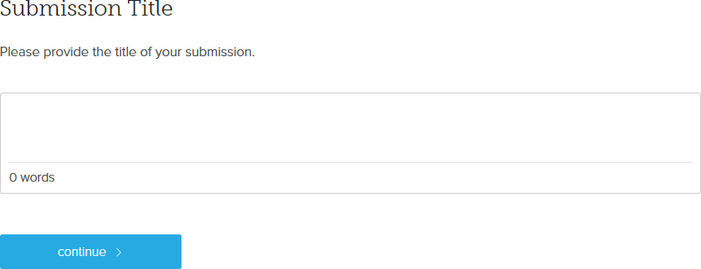

### Step 3: Short Abstract

Please provide a short abstract for your proposal.

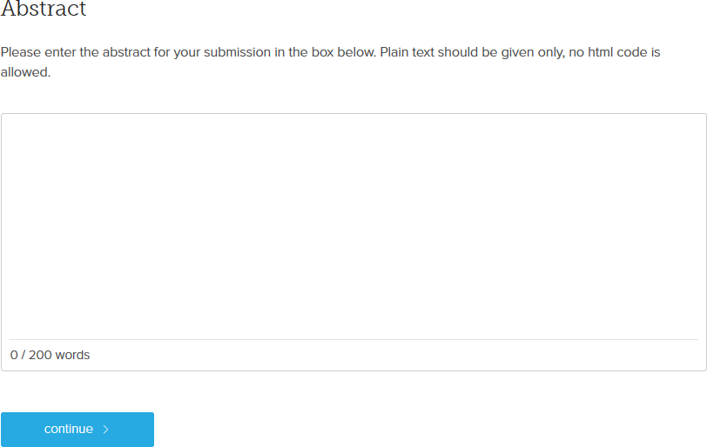

### Step 4: Keywords

Please provide a minimum of 3 keywords.

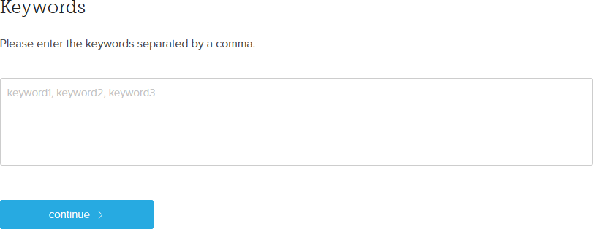

### Step 5: Authors

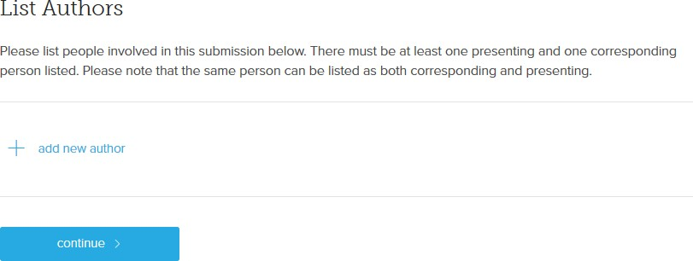Please input details for each author and mark them with appropriate roles. Corresponding authors will receive updates and information regarding the submission. Authors not marked as presenter, convenor or corresponding, will only receive an initial notification of submission.

### Step 6: Subthemes

Please select the most appropriate subtheme for your proposal. We will use the topics and the short abstract to allocate reviewers to your proposal. If more than one topic fits your proposal, please select the most appropriate one. If none fits, please select ‘Other’.

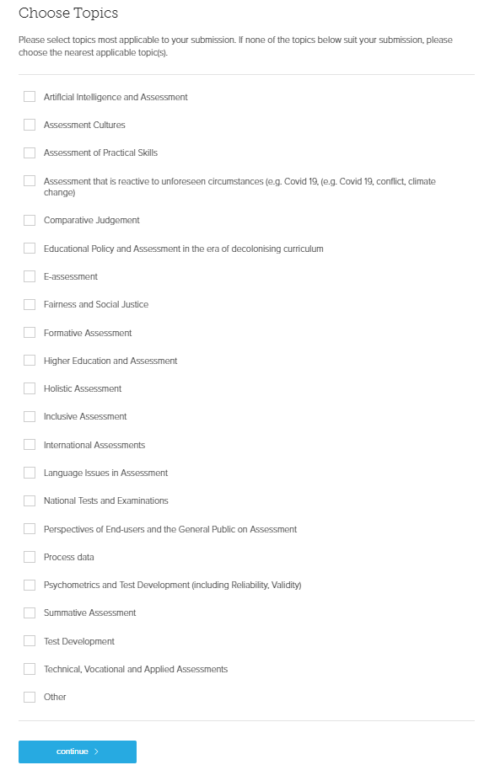

### Step 7: Long Abstract Upload

Please upload your long abstract in PDF or Word format.

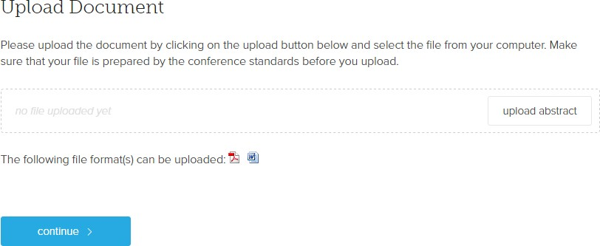

### Step 8: Attachment

If you are submitting a Workshop, the Attachment step will appear. The link to the application form is

<https://2024.aea-europe.net/wp-content/uploads/2024/02/APPENDIX-A-1.docx>

Complete the form (Sample in Appendix A) and upload it as part of your submission.

### Step 9: Special Interest Groups

### 

### Step 10: Submit

If you are happy with the summary information, please click on Submit Now to finalize the process, and a notification e-mail will be sent to all authors.

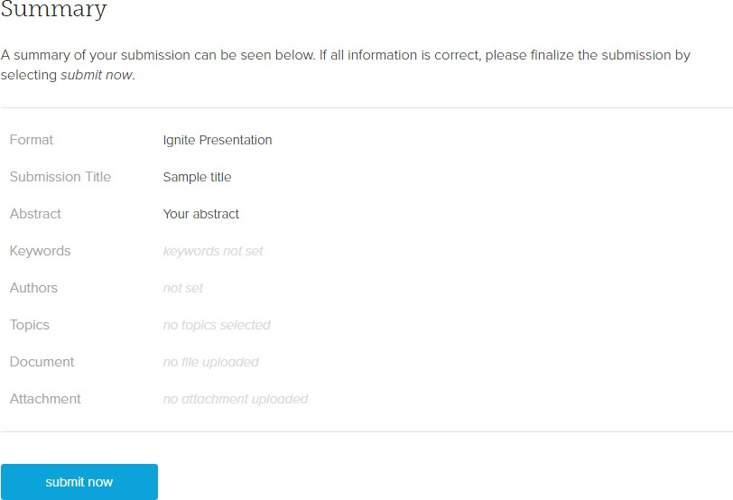

# APPENDIX A: Template pre-conference workshop

**WORKSHOP TITLE:**

**Presenters:**

**Presenters’ bios (500 words max per presenter):**

**Why AEA-E members / conference delegates should attend this workshop:**

**Who this workshop is for:**

**Overview of workshop (500-600 words):**

**Preparation for the workshop:**

**Tentative Schedule**

|  |  |  |
| --- | --- | --- |
| **Time** | **Session** | **Presenter** |
| 9.30-  12.00  (Inc. a 15 min break 10:30-11:00) | Block I |  |
| 12.00-  13.00 | Lunch |  |
| 13.00-  14.30 | Block II |  |
| 14.30-  14.45 | Tea/coffee break |  |
| 14.45-  16.30 | Block III |  |

### APPENDIX B: Setting up an account with EasyAcademia.

Go to [www.easyacademia.org](http://www.easyacademia.org) and click on the “Get Started” button.

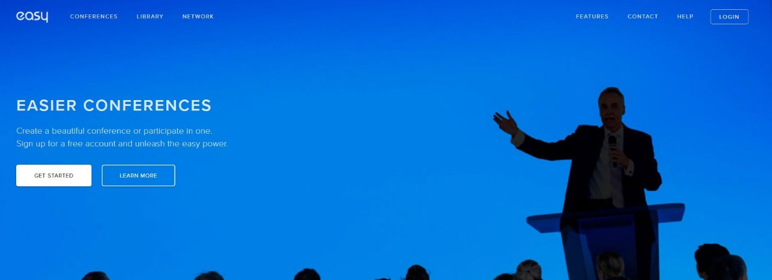

This link will bring up a signup page:

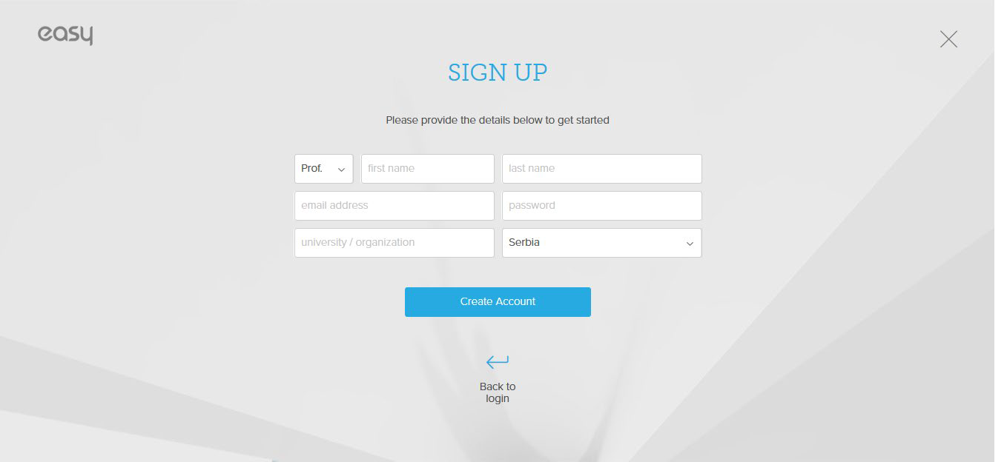

Follow the on-screen instructions and complete the form and click on “Create Account”.

Now, you will receive an email with the activation code. Use the link provided in the email to verify your account.

N**ote**: Please check your Spam folder if you have not received the email within a few minutes.

N**ote:** If your email appears taken, it is possible that you have signed up for EasyAcademia in the past for another conference. In this case, you simply need to ask the system to remind you of your password based on your email.